**WEB_ICP5**

DHARMA TEJA K

Email: [dkbmy@umsystem.edu](mailto:dkbmy@umsystem.edu)

GitHub Link:

Avinash Reddy T

Email: [atfkh@umsystem.edu](mailto:atfkh@umsystem.edu)

GitHub link:

**In Class Programming:**

**NODE JS:**

Node. js is best suited for non-blocking, event-driven servers, because of its single-threaded nature. It was created with real-time, push-based architectures in mind and is utilized for standard web sites and back-end API applications.

Node.js is a cross-platform, open-source back-end JavaScript runtime environment that uses the V8 engine to execute JavaScript code outside of a web browser.

**ANGULAR:**

Angular is a Typescript-based programming framework. Angular as a platform includes:

* A framework for developing scalable web applications based on components.
* A set of well-integrated libraries that cover a wide range of functions, such as routing, forms management, client-server communication, and more.
* A set of developer tools for writing, building, testing, and updating code.

It comes as a set of TypeScript libraries that you can import into your applications to implement core and optional features.

**Todo_EventCounter**

To ensure that people remember a specific task, one can develop a to-do list. It can contain any assignment or goal that needs to be met on time. The to-do list's main purpose is to remind a person of the tasks that need to be completed. It also aids in the reduction of time waste.

If you want to avoid work overload, you'll need to make to-do lists. You'll appear unfocused and unreliable to those around you if you don't use them effectively.

Let’s start,

Both the To-do and Countdown Timer in a single application and shown below.

After developing the project,

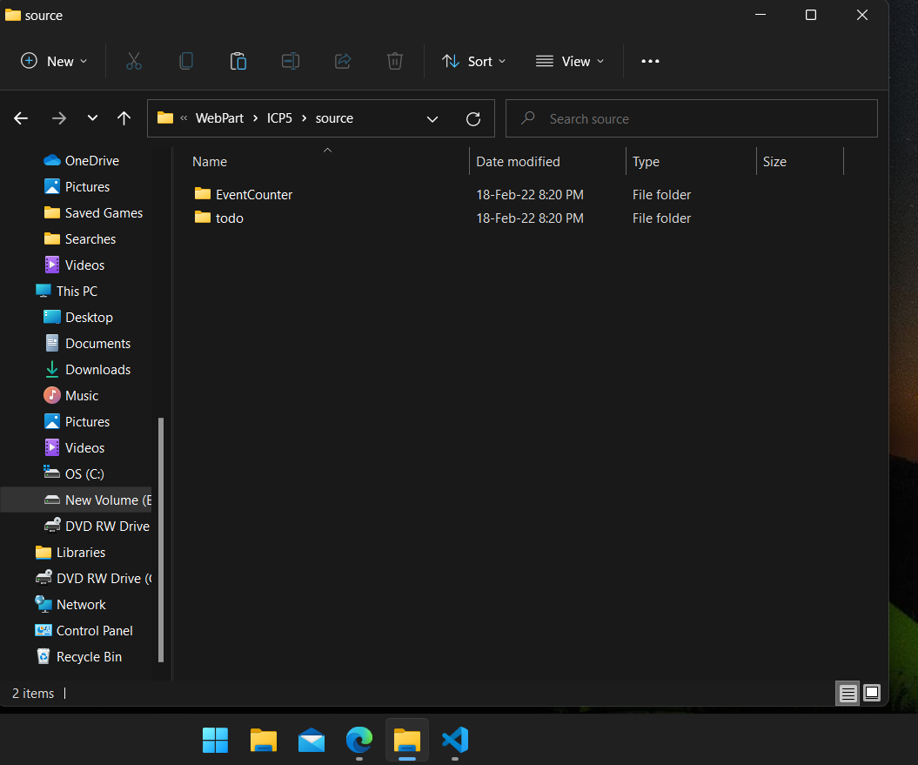

Open command prompt from the file path as shown below, for reference

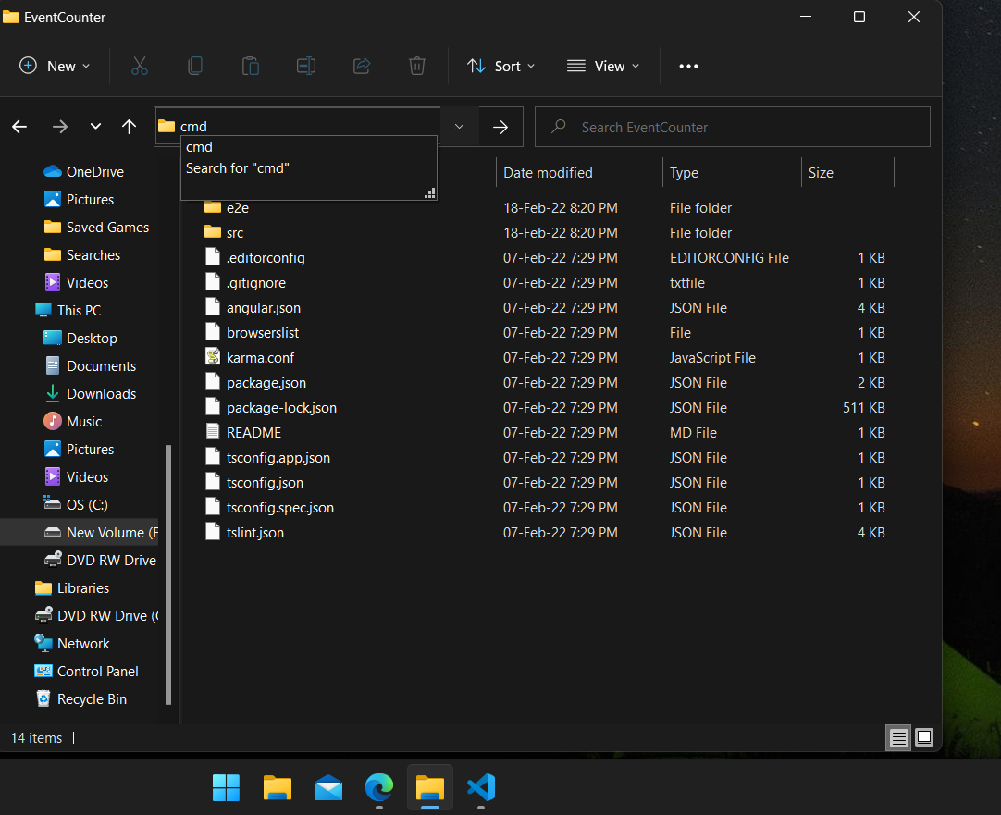

**HTML** code:

Below are the screenshots of html code developed to build our application

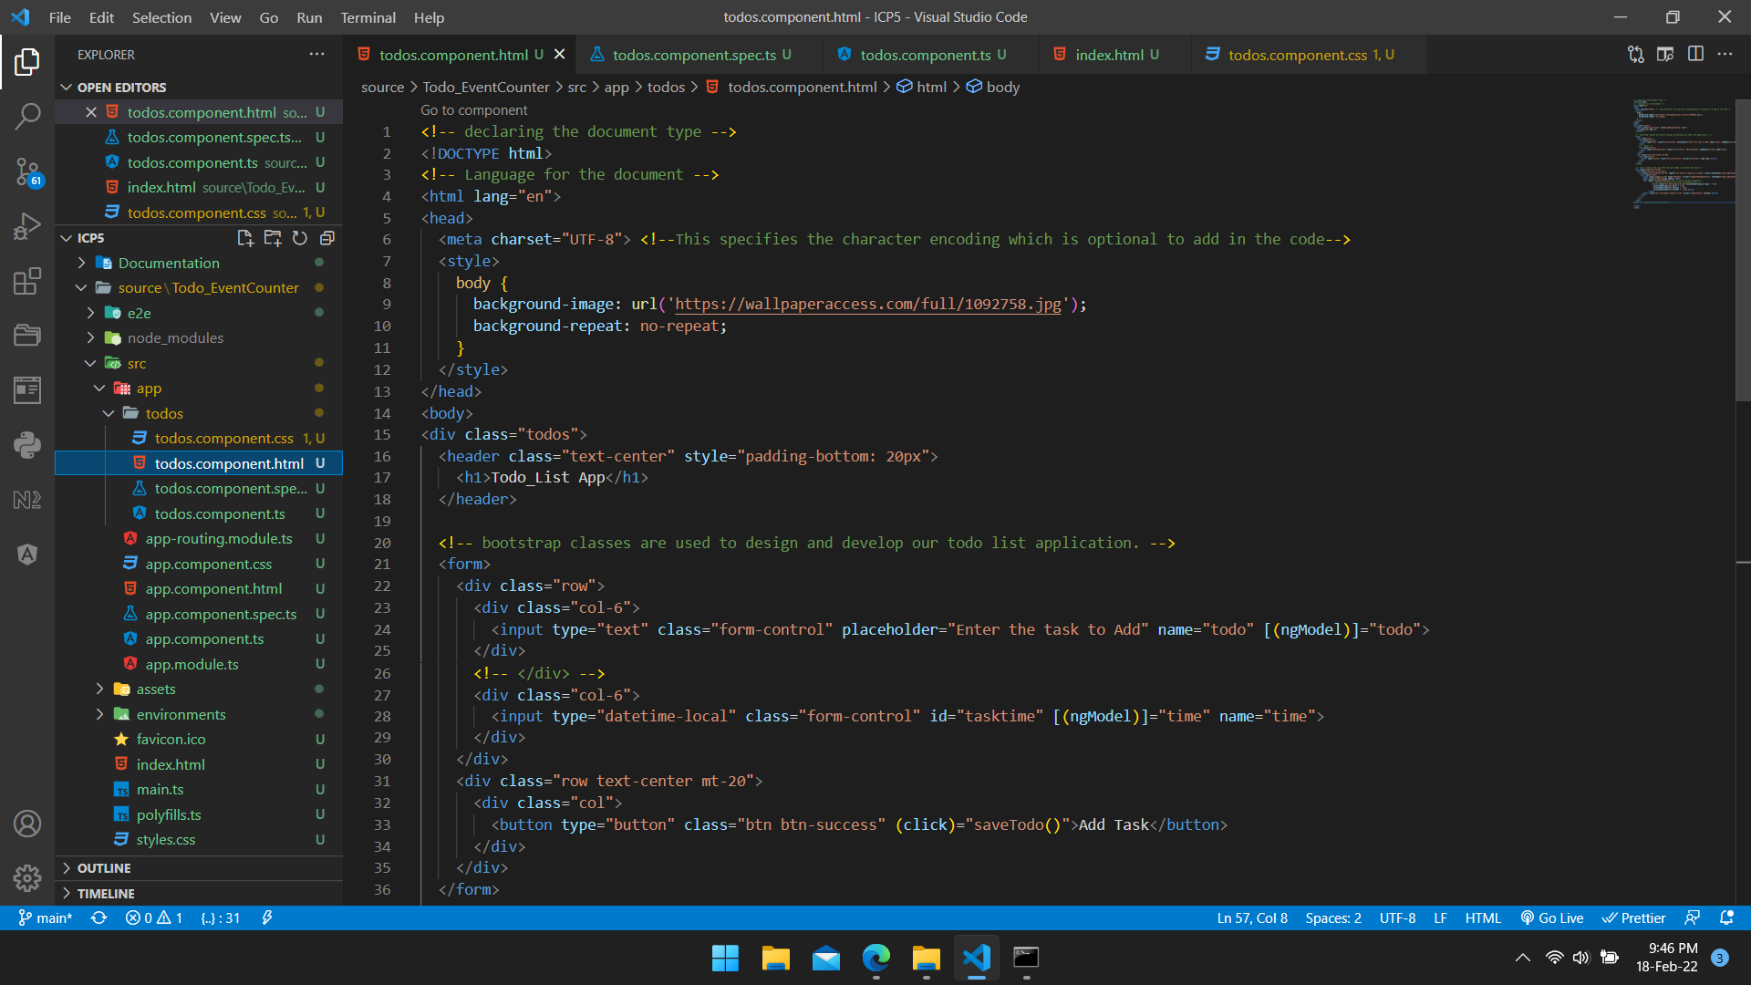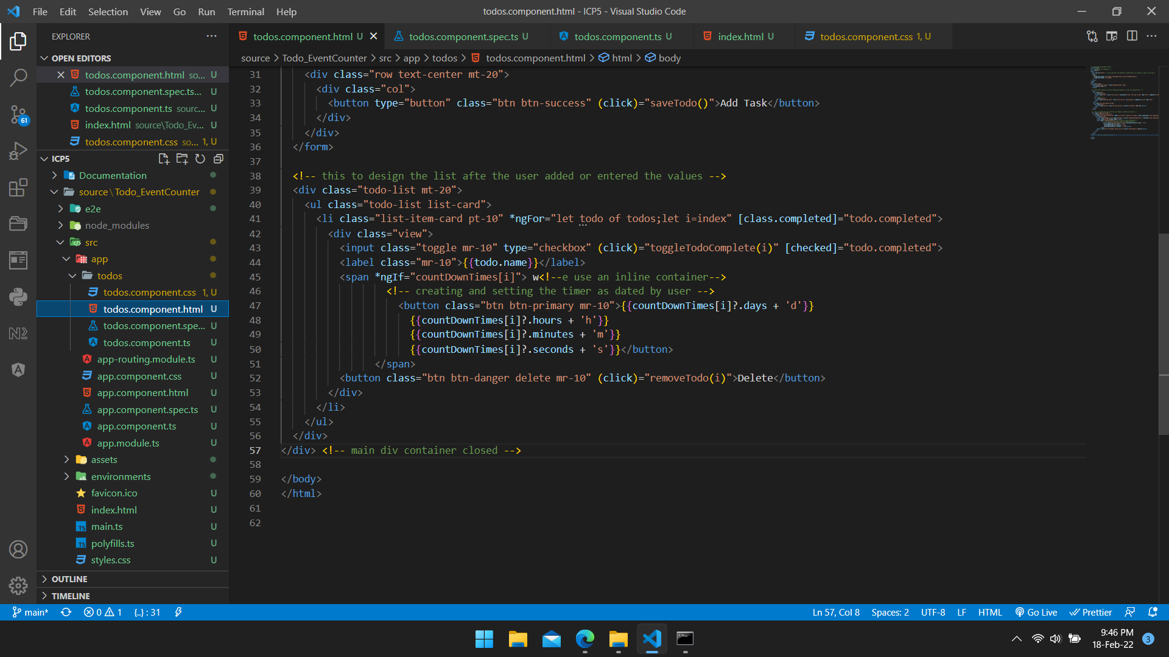

Below is the snap of angular spec,

Unit tests for your source files are contained in the spec files. For Angular apps, it is standard to have a.spec.ts file for each.ts file. When you use the ng test command, they are run using the Jasmine javascript test framework using the Karma test runner.

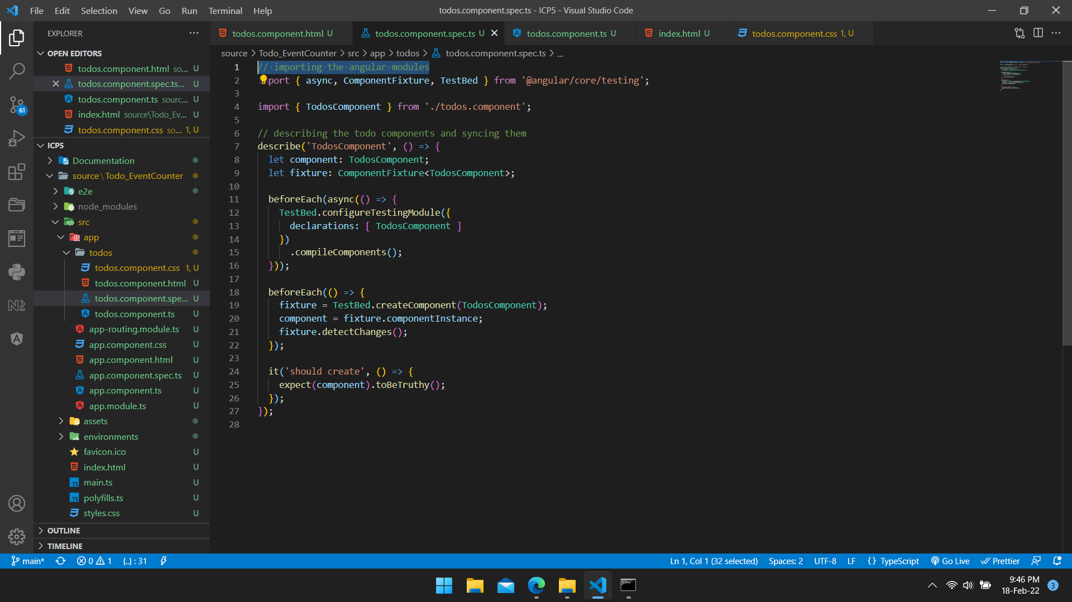

**ts** code:

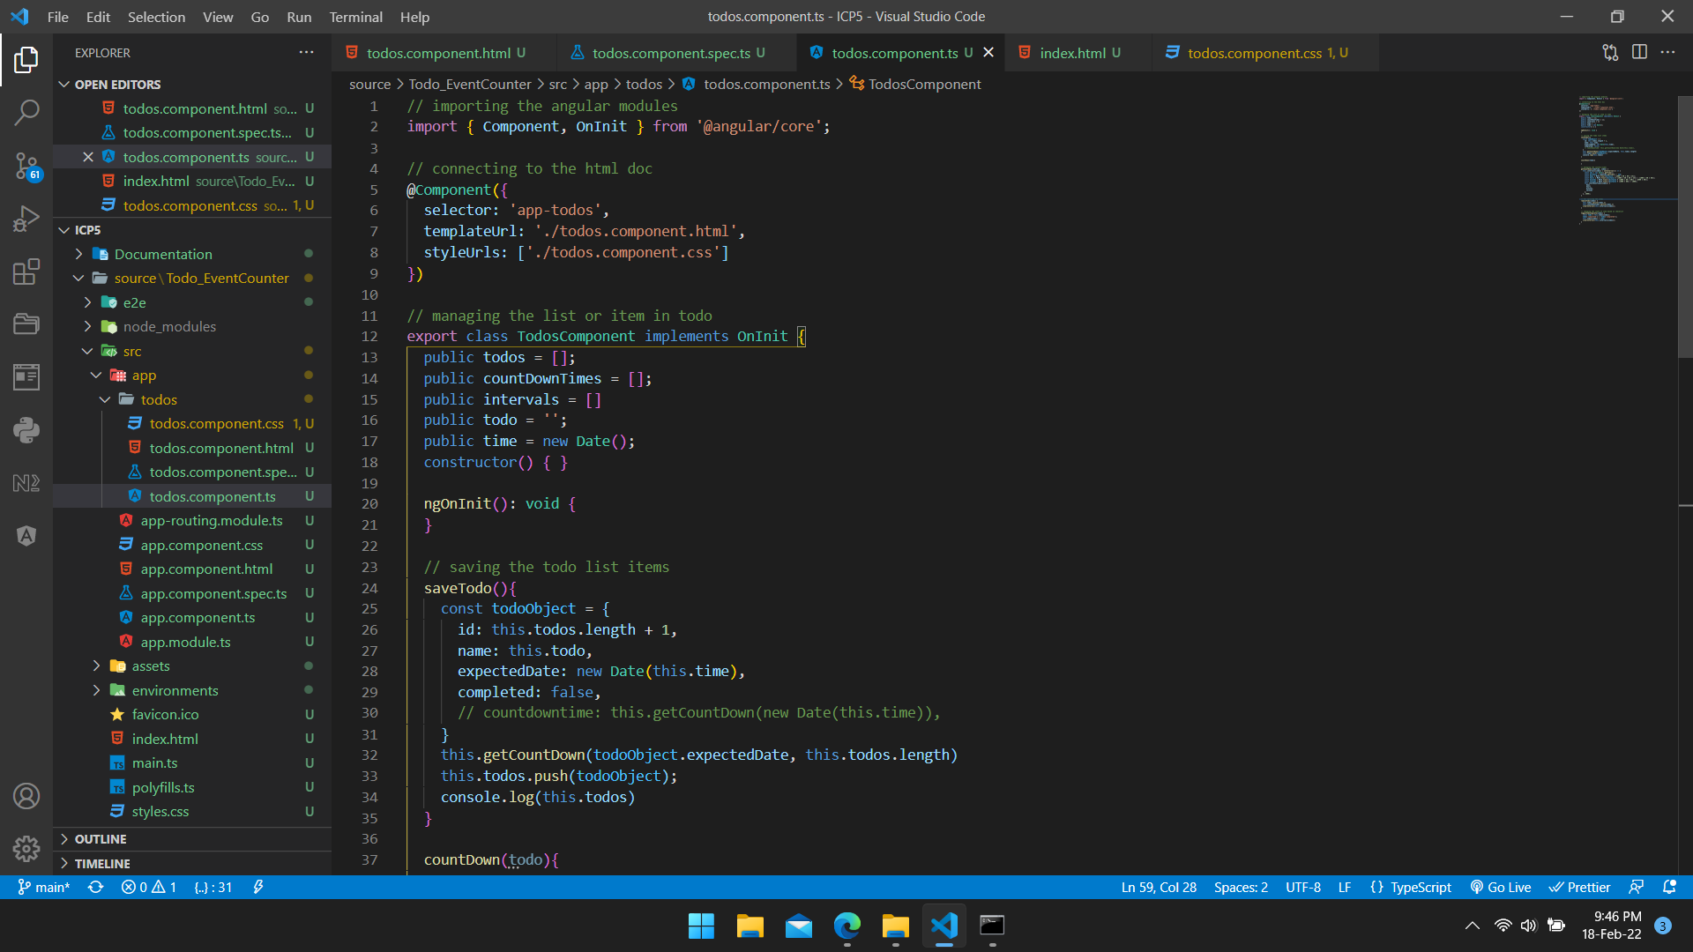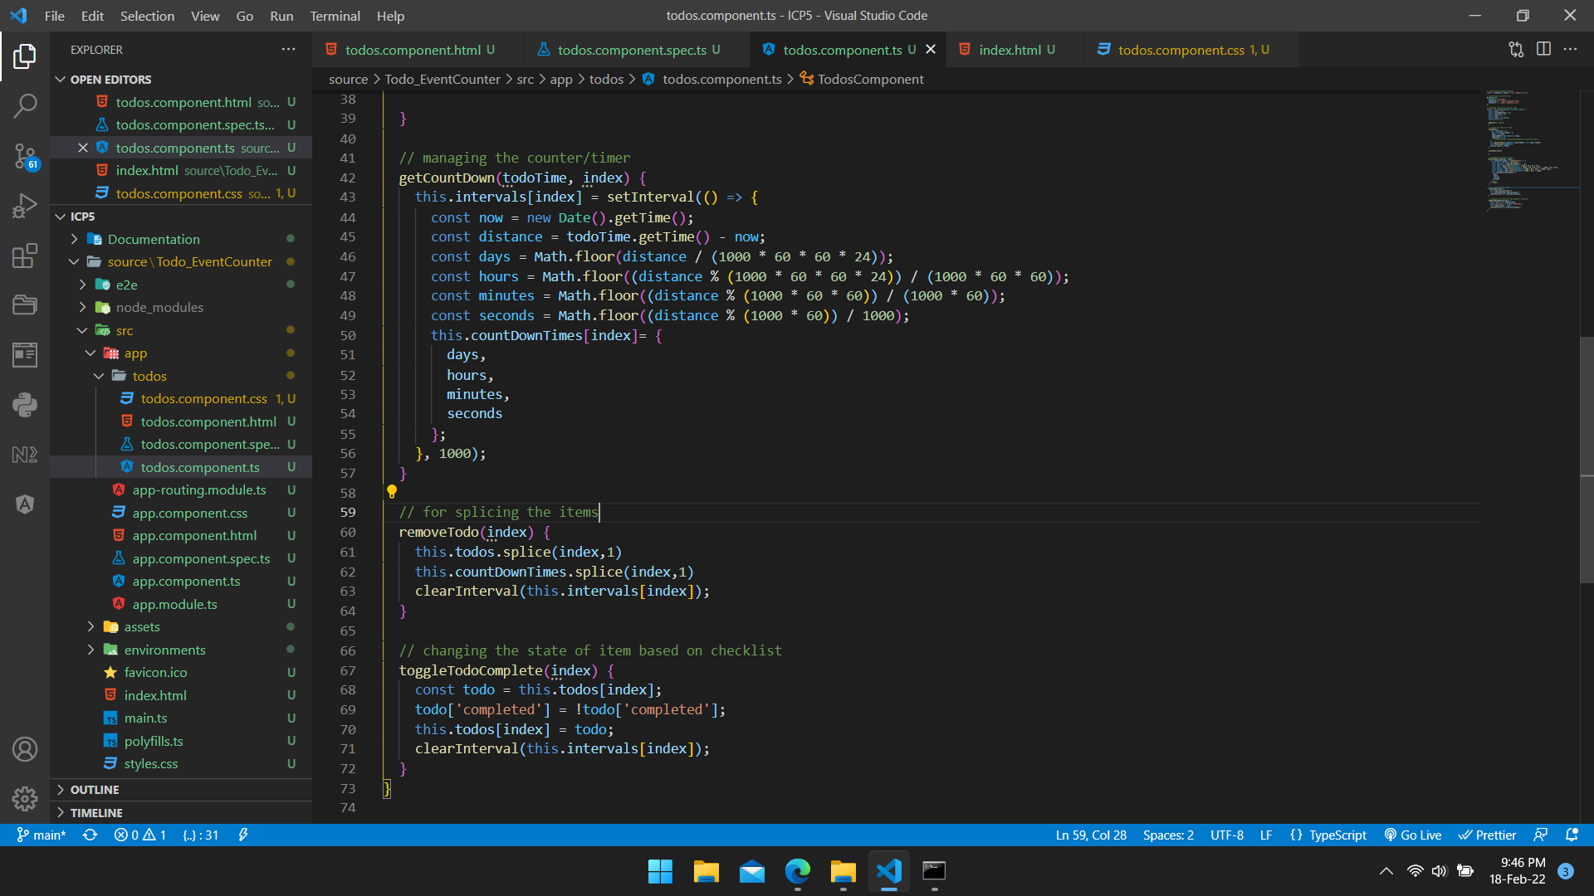

**CSS** code:

Below is the css code used to design our application.

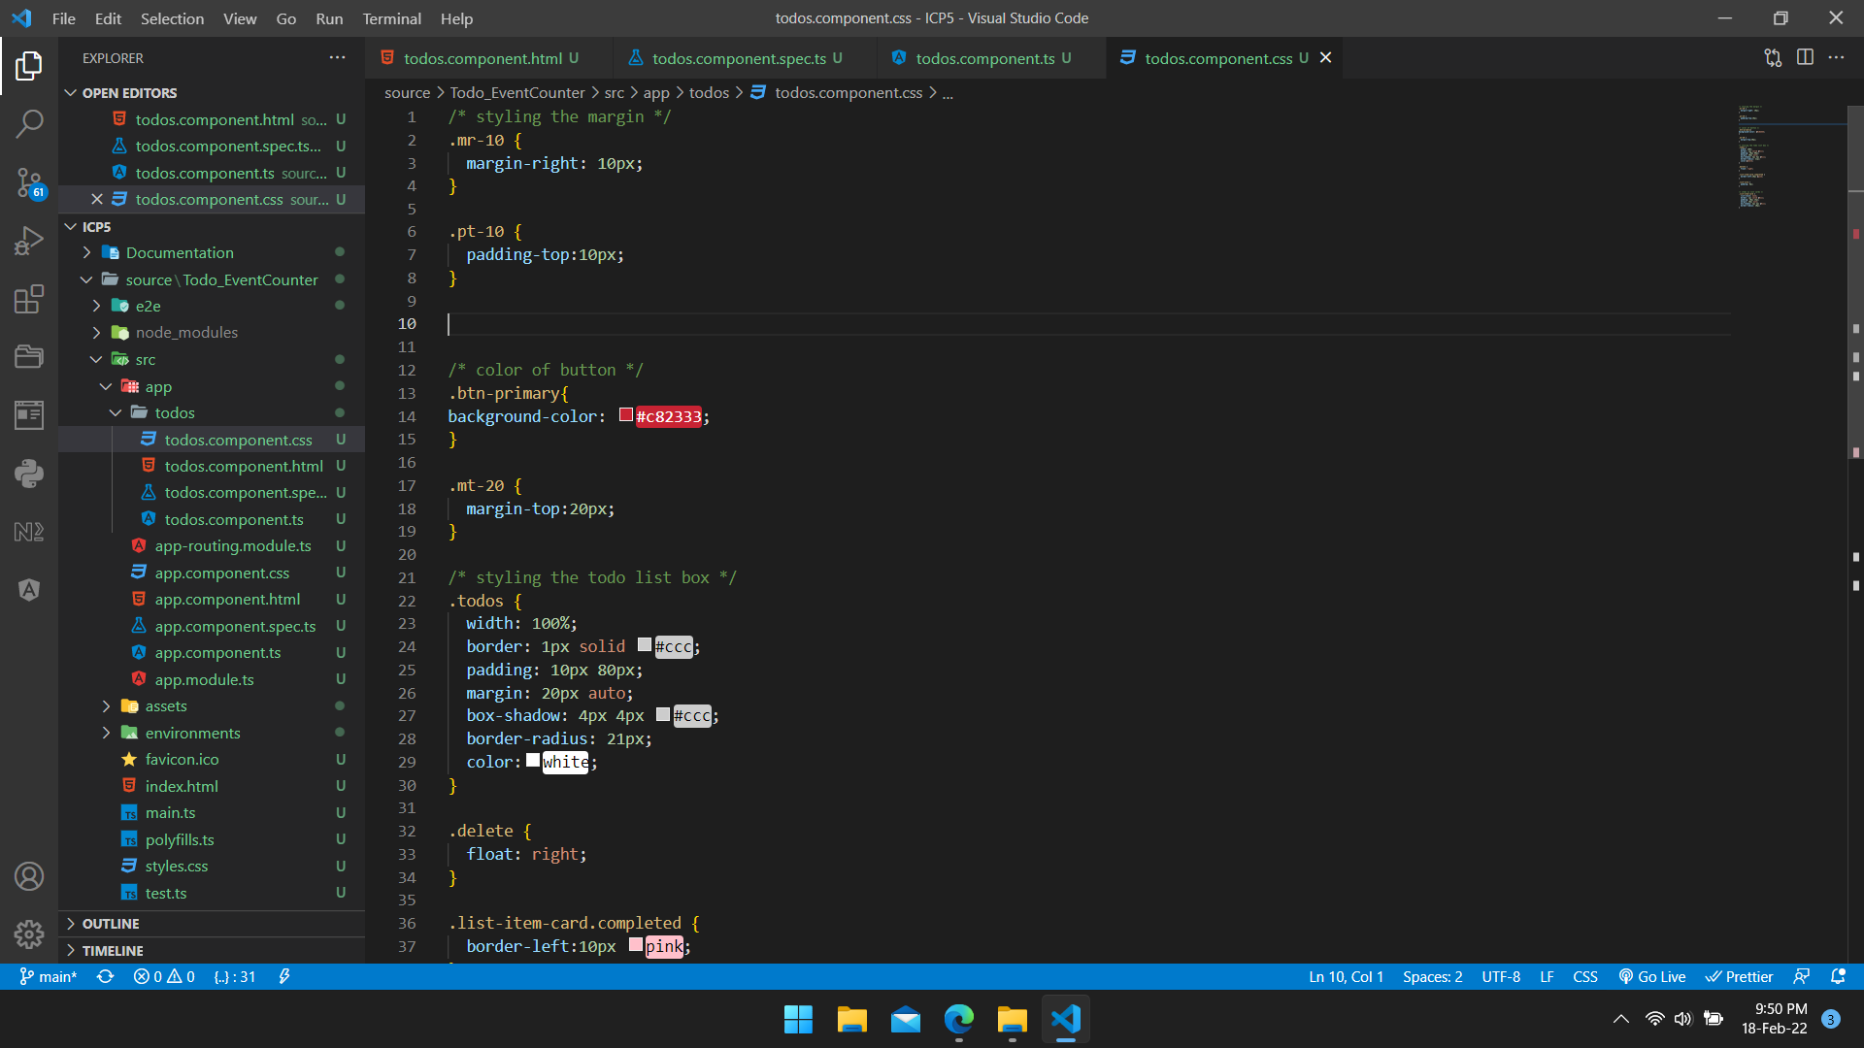

Now, install the node modules using npm command “npm node-modules --save” as shown in the snap below.

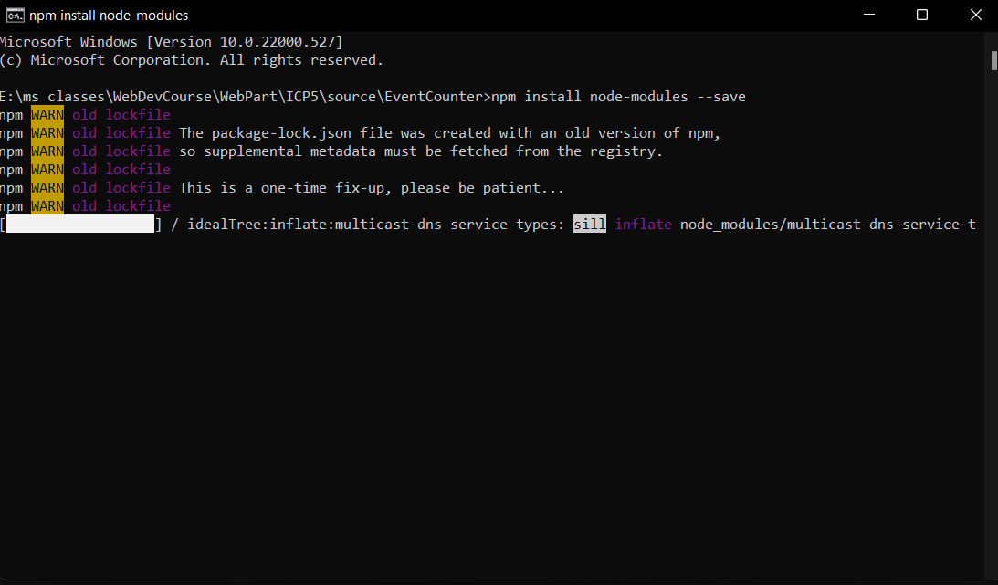

After getting the node files into your project destination, run the application as shown in the screenshot below.

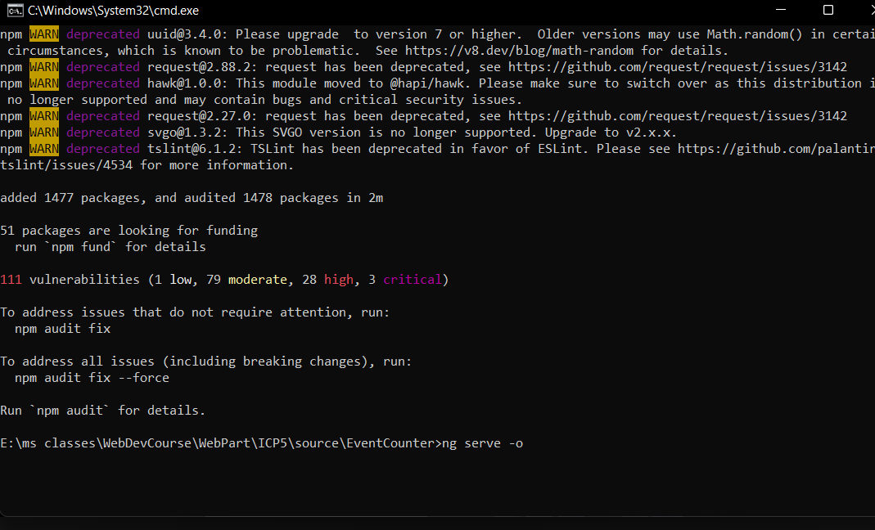

**OUTPUT:**

Enter the value and set the timer as needed, below is the reference to the same.

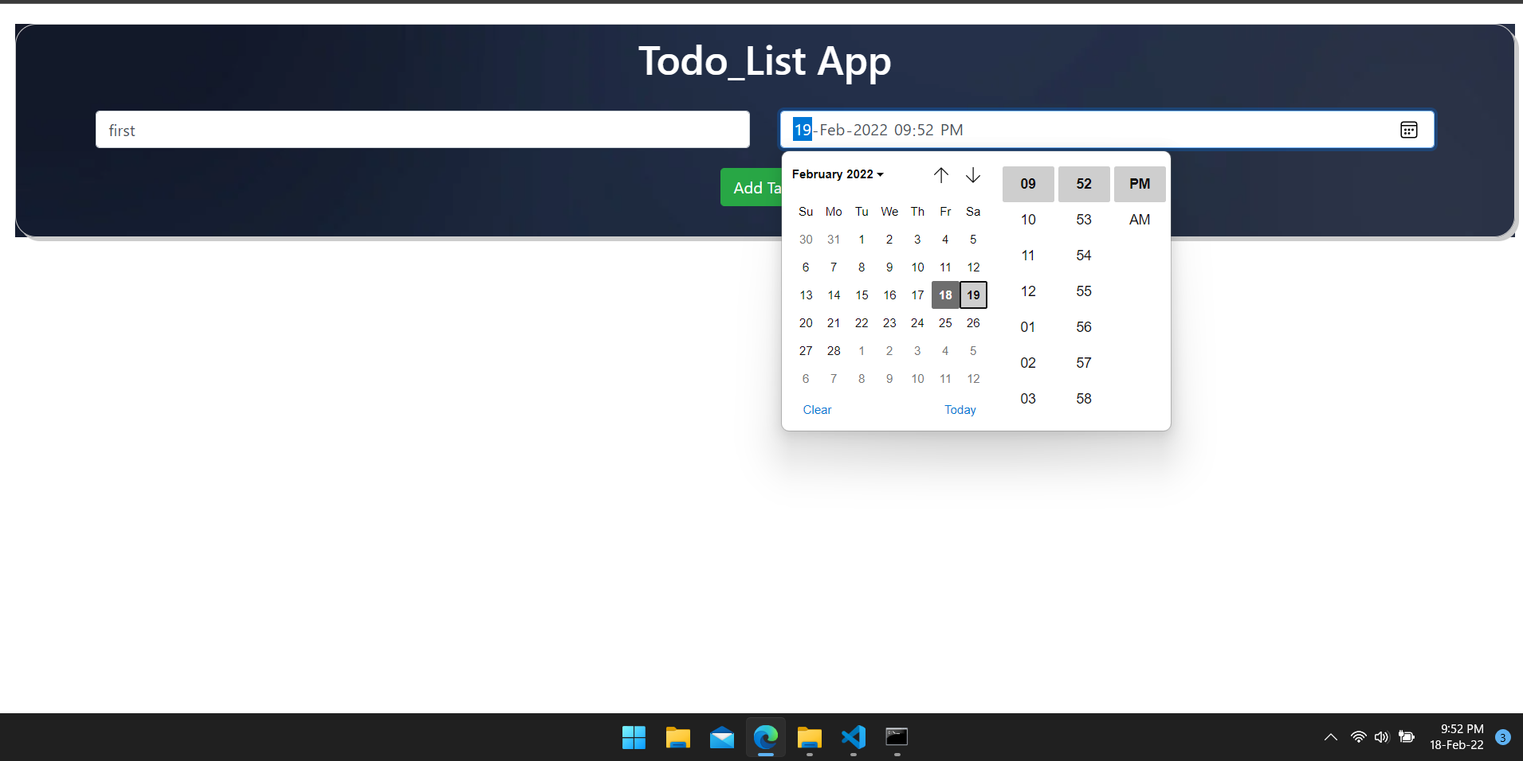

Next, add the item to the list which is then displayed as below.

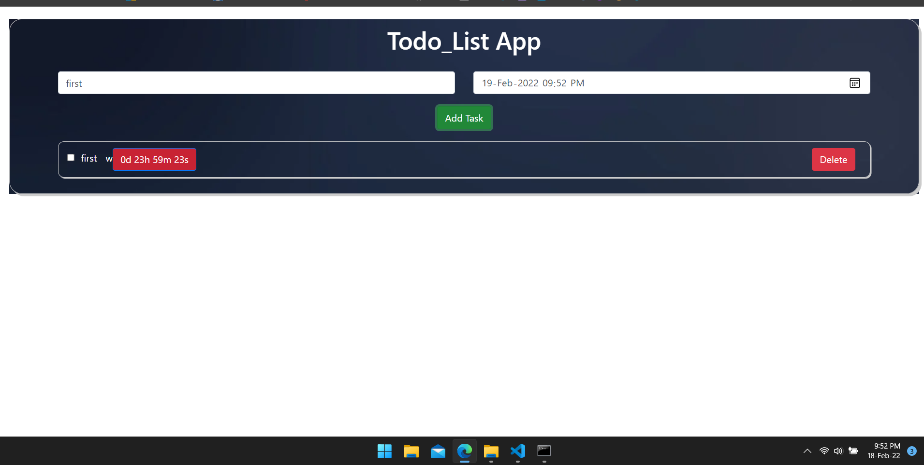

Items added can also be deleted when done or when required.

Similarly, multiple list of activities can be added and managed through the application.

